UBC GHI acute disaster relief workshop
K. Joughin, 26 September, 2012
Scenario 1
You are on holiday with a small group of health professional friends. You stop in Dhaka, Bangladesh for several days, en route to Nepal. The day after your arrival in Dhaka you hear on the BBC news that a massive earthquake has hit Chittagong, population 4 million. There is extensive destruction and mass casualties.

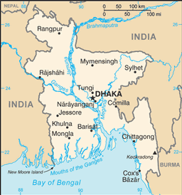

- What will the survivors/local population in Chittagong need?
- What are you going to do and why (be specific and provide detail)?
- What pros and cons did you consider in your decision?
- What limits your ability to help?
- What personal gains might people providing aid get?

